**Front View**

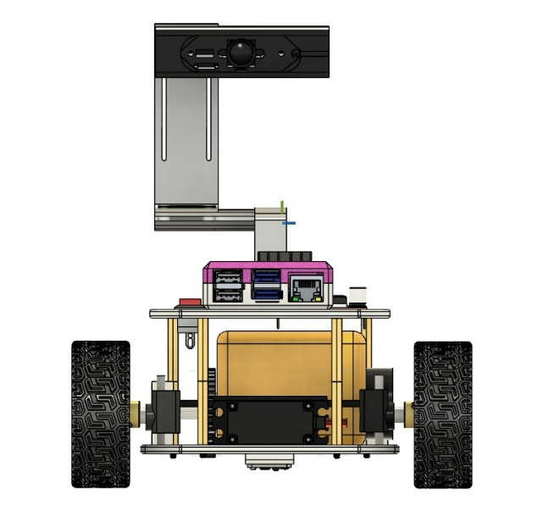 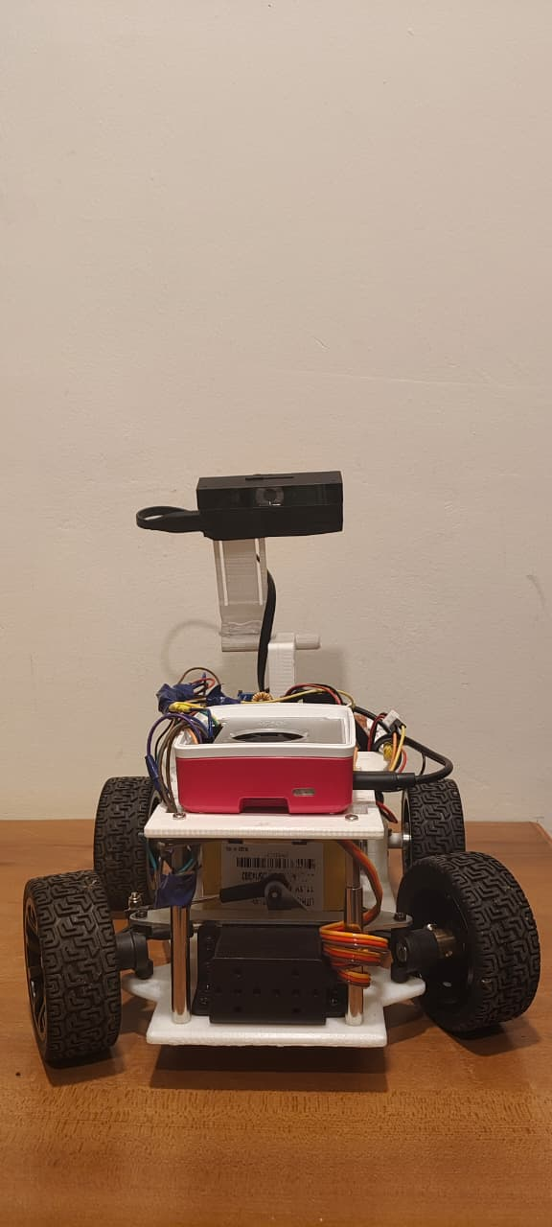

**Back View**

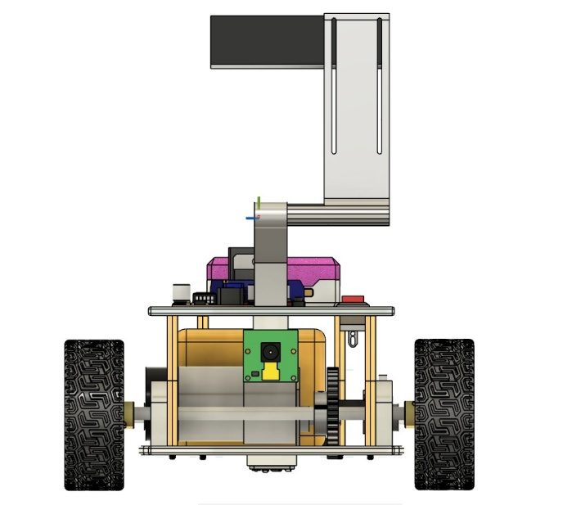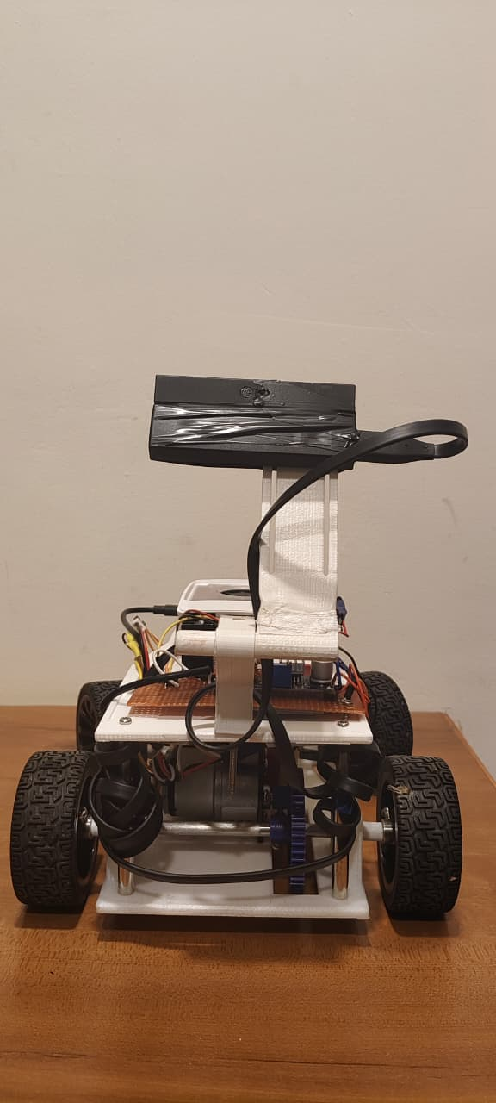

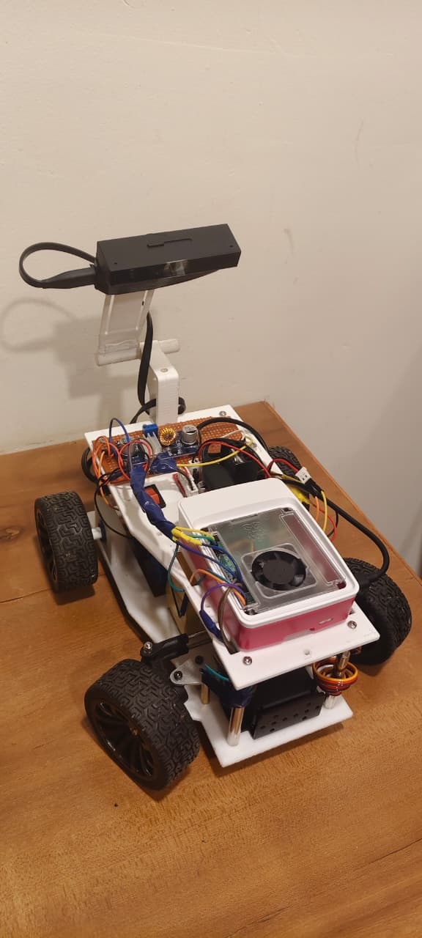**Isometric view**

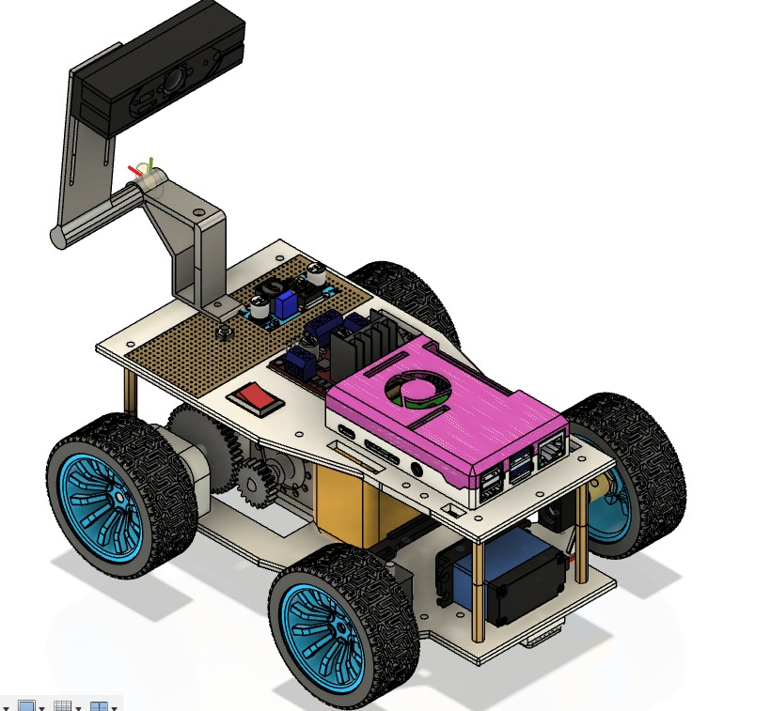

**Left Side View**

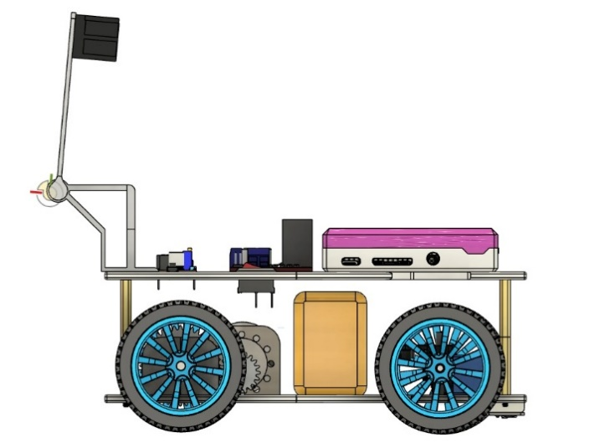**Right Side View**

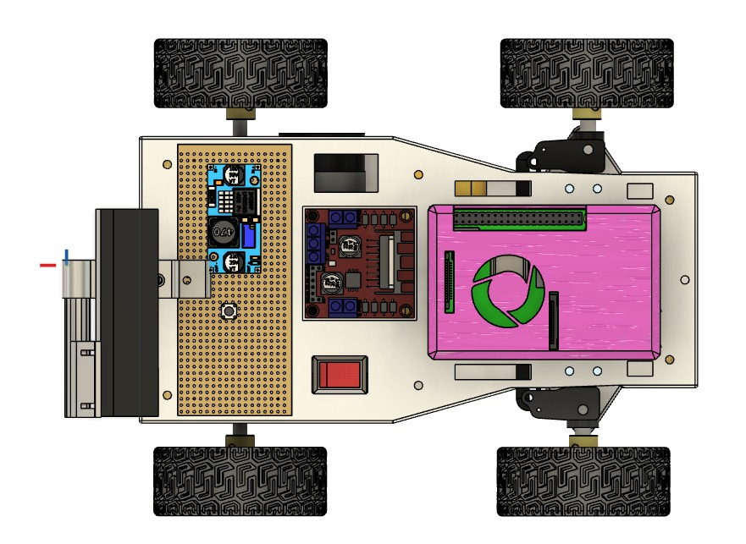**Top View**

**Bottom View**

